TravelBooster REST APIs

Updated date: 17/12/2024
Version 1.1.2

Introduction

Travelbooster’s API platform enables you data communications with Travelbooster’s platform without using Travelbooster’s UI.
In order for you to do so, you must be familiar with REST API protocols.

Getting Started

- Get your API credentials (client_id & client_secret) – Ask your customer manager for your dedicated credentials. You will not be able to use Travelbooster’s API without it.
- Get API’s Swagger documentation – In order to get your API’s Swagger you can simply navigate to https://tbapi-sandbox.travelbooster.com/swagger/v1?client_id={{client_id}}.

Swagger file

What is Swagger
You can read more about Swagger here:
https://swagger.io/
https://en.wikipedia.org/wiki/Swagger_(software)

What should you do with your Swagger
Navigate to https://editor.swagger.io/ and paste your Swagger’s JSON in the appropriate place.
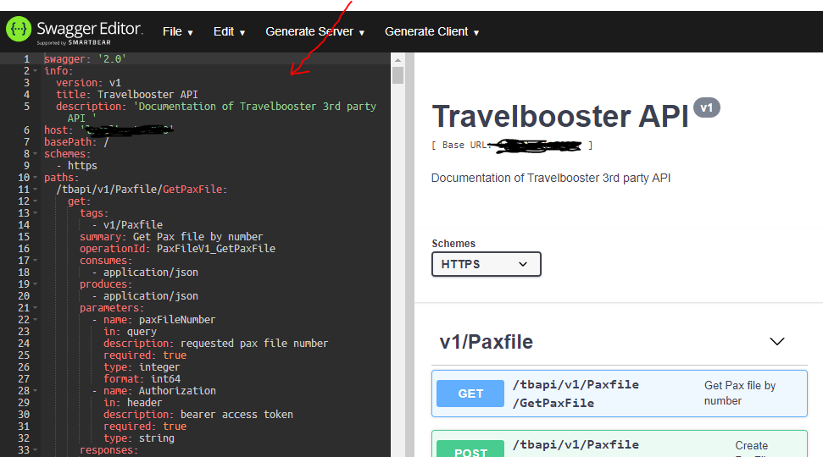

Is it possible to use Swagger editor to perform your http requests ?
YES
Choose the API you want and click on the “Try it out” button, fill in the relevant parameters and perform your request.

Authentication
We are using 2-step authentication OAuth2.0 protocol.
In order for you to be able to use our API, you must first authenticate yourself using the credentials given to you by your customer manager.
Your credentials include a dedicated client_id and client_secret tokens.
Output of authentication process is a JSON includes several attributes (“access_token”, “refresh_token”, “expires_in”, “token_type”).
Use “access_token” token for each and every API request (as described on Step 2 below).
The authentication process must be carried out before every Session or API business flow.
Additionally your token will only be valid for a specific amount of seconds as described in expires_in attribute.
For example if your authentication output is:
{ "token_type":"Bearer", "access_token": "106bfc34a..", "refresh_token": "f5d8a428f1..", "expires_in": 2000 }
Your token will then be valid for 2000 seconds.
Ensure that each session/API business flow (not just a single request) initiated by an end user starts with an authentication step (auth/token). Avoid using a single auth/token and sharing it across all end users and their actions.

Authentication process

Step 1:
This http-request is not supported using Swagger editor since response is being redirected. You can use Chrome browser/Postman etc.

Send GET http-request to https://tbapi-sandbox.travelbooster.com/auth/auth? with the following query string parameters:
client_id a valid clientId provided to you by your customer manager
redirect_uri the final URL the response is redirected to
scope “login”
response_type “code”
state you can provide us with a state that will be returned to you as a query string parameter on the redirected url. This is free for you to use as you wish.

The TravelBooster supports two types of users:
- Machine: the user will be automatically redirected to “redirect_uri”.
- Human: the user will be redirected to a login page from which he will be redirected back to “redirect_uri” upon successful completion.
The response for both types of users will be identical once the authentication step is completed successfully.
For example:
If you will send us this http-request:
https://tbapi-sandbox.travelbooster.com/auth/auth?client_id=289fc2fe63ff0&redirect_uri=[redirect_uri]&scope=login&response_type=code&state=foo

You will receive this http response:
HTTP/1.1 302 Found
Access-Control-Allow-Origin: *
Access-Control-Allow-Methods: *
Access-Control-Allow-Headers: *
Location: [redirect_uri]?code=773d88b089&state=foo
Vary: Accept
Content-Type: text/plain; charset=utf-8
Content-Length: 792
Date: Sun, 02 Aug 2020 18:29:41 GMT
Connection: keep-alive

Found. Redirecting to [redirect_uri]?code=773d88b089&state=foo

Step 2:
This http-request and all other requests are supported using Swagger editor (Responses other than http-status-code 200 are not supported). You can click on the “Try It Out” button, fill out all fields and execute requests.
Send POST http request to https://tbapi-sandbox.travelbooster.com/auth/token? With the following x-www-form-url-encoded body parameters:
code The code you got from the first step
client_id a valid clientId provided to you by your customer manager
client_secret a valid clientSecret provided to you by your customer manager
grant_type “authorization_code”
redirect_uri The same URL that was provided on auth request.

For example:
If you send us this http request:
POST https://tbapi-sandbox.travelbooster.com/auth/token HTTP/1.1
User-Agent: XYZ
Accept: */*
Cache-Control: no-cache
Host: tbapi-sandbox.travelbooster.com
Connection: keep-alive
Content-Type: application/x-www-form-urlencoded
Content-Length: XYZ

code=773d88b089&client_id=289fc2fe63ff0&client_secret=13b5a43d382&grant_type=authorization_code& redirect_uri=[redirect_uri]

We will return this http response:
HTTP/1.1 200 OK
Access-Control-Allow-Origin: *
Access-Control-Allow-Methods: *
Access-Control-Allow-Headers: *
Content-Type: application/json; charset=utf-8
Content-Length: XYZ
Date: Sun, 02 Aug 2020 18:37:56 GMT
Connection: keep-alive

{"access_token":"0d8dcc4b6381db2156","token_type":"Bearer"}

Access token is your authentication token, you will send it on each API request as header parameter (e.g. Authorization: Bearer 0d8dcc4b6381db2156).

Are there Postman templates that I can use?
You can use your Swagger to generate a Postman collection for all requests.
Just import your Swagger as Raw Text and start using Postman.

How to generate Postman templates from a Swagger
- Run Postman.
- Press Ctrl+O (Import).
- Go to ‘Raw Text’ Tab and paste your Swagger.
- Press ‘Continue’ and ‘Import’.
- Have fun and Do Your Magic.
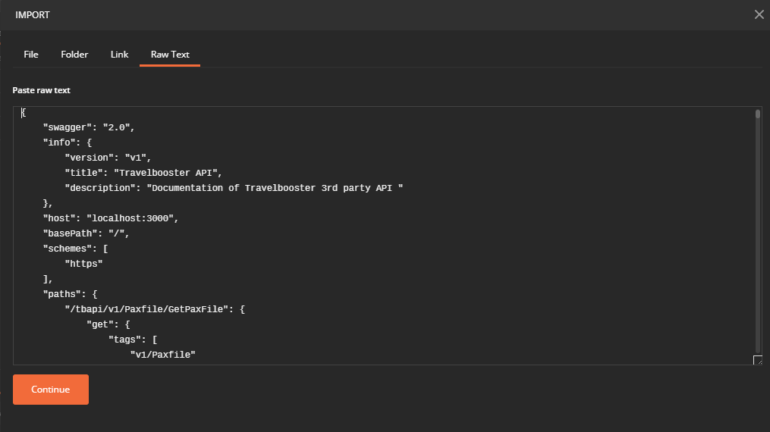

How to use Travelbooster API
Once you have the access_token you can use all relevant APIs mentioned in your Swagger editor/Postman/etc...
Make sure you use the bearer token authentication type by writing “bearer” followed by space and then the actual access_token in the authorization field under the request-header.
For example, In Postman:
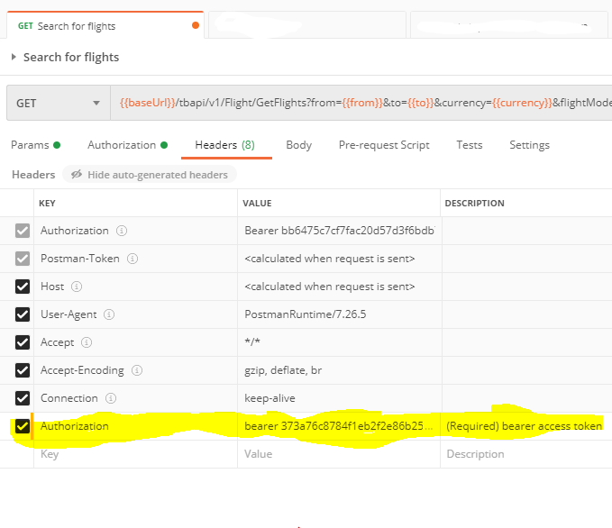
When building your application please take into considerations that the API might change with non-breaking changes – so code accordingly.

Travelbooster API Certification process
In order to use Travelbooster API in live environments, customers must successfully complete the ‘Travelbooster API Certification’ process.

The certification process includes several steps:

Authentication process validation
Customers should be able to pass the authentication process using OAuth2.0 protocol.

Web method validation
Each and every web method should include all [required] parameters and should not include unrelevant parameters. Use only the specified model as declared on Swagger.

Flow validation
Make sure that the web methods flow is valid (sample flows can be seen on postman collections).
Ensure that each session/API business flow (not just a single request) initiated by an end user starts with an authentication step (auth/token). Avoid using a single auth/token and sharing it across all end users and their actions.

AccessToken expiration validation
Each AccessToken has an expiry time. You should be aware that after the expiration time, the AccessToken will no longer be valid. You must therefore handle AccessToken expiry (e.g. refresh process or new tokanization process).

